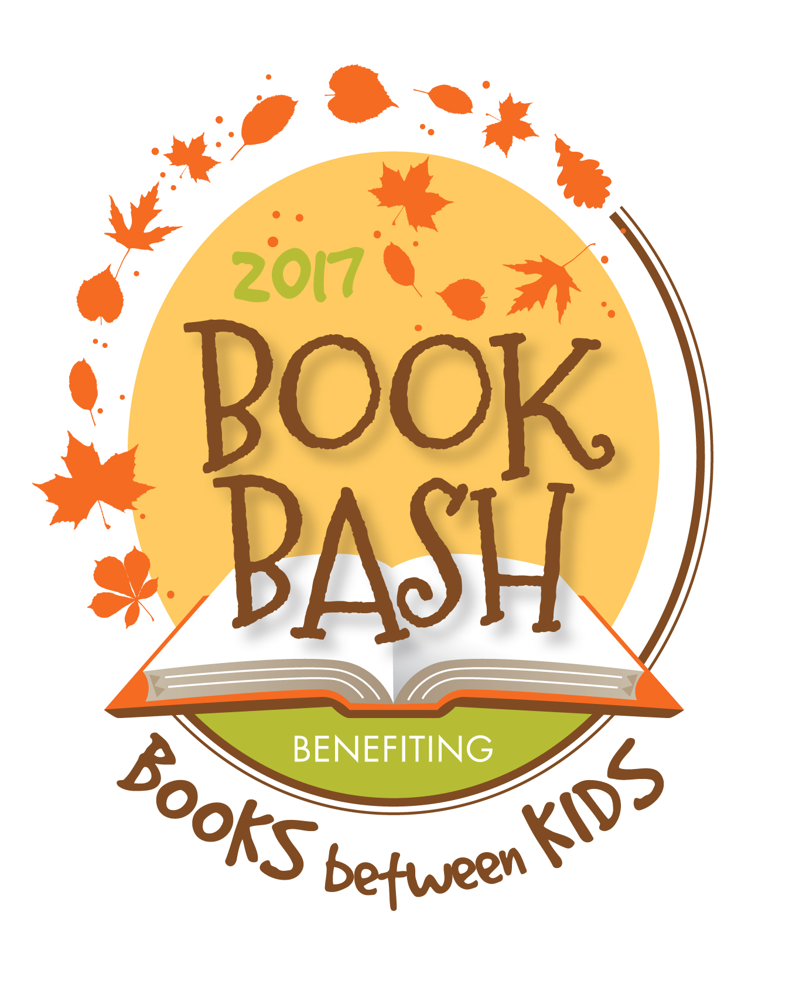
Wednesday, November 8, 2017 from 6:30-9:00pm
The Armadillo Palace * 5015 Kirby Drive * Houston, TX 77098
Benefiting Books Between Kids

Tickets and Tables

___$2,000 Literacy Leader Sponsor
One table for eight (8) guests in prime seating
Recognition in the invitation and signage

__$600 Reading Enthusiast Sponsor
Seating for four (4) guests in preferred seating
Recognition in the invitation and signage
___$500 Book Buddies Sponsor Couple
Two (2) tickets in preferred seating
Recognition in the invitation and signage
___$100 Chapter Champs Ticket
One ticket in general seating
_____(# of tickets) = $____

__I cannot attend but would like to make a tax-deductible donation of $________

__Cash
__Check Please make checks payable to Books Between Kids.
__Credit Card Please visit www.booksbetweenkids.org/fundraiser to pay by credit card.
Contact Name:______________________________________________________________

Name: _______________________________________________________________
(As you wish it to be listed in printed materials.)

Phone Number: ________________________ Email: ______________________________

Mailing Address: ___________________________________________________________

___________________________________________________________

(Donations must be received before Nov 1 to be recognized in the program.)

Please mail donations to:
Books Between Kids
P.O. Box 25072
Houston, TX 77265

For more information, please contact Jamie Grissom
jamie@booksbetweenkids.org or 832-831-1402
Books Between Kids, Inc is a 501(c)(3) organization. www.booksbetweenkids.org

